OLADIMEJI ALADEROKUN

219047012

SSG 817

ASSIGNMENT 2

1.

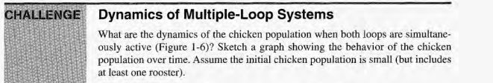

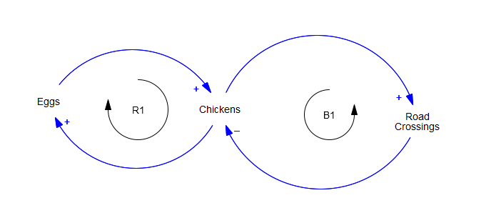

A hypothesis is that in the case where the Reinforcing loop is dominant, the number of chickens will grow exponentially. When the Balancing loop is dominant, the number of chickens will decline to either zero, or some small number, dependent on the dynamics of egg laying. A model was constructed using Vensim to investigate the dynamics of each loop in isolation, and then combine the two to examine the joint behavior.

The Causal Loop Diagram into an actual stock and flow model;

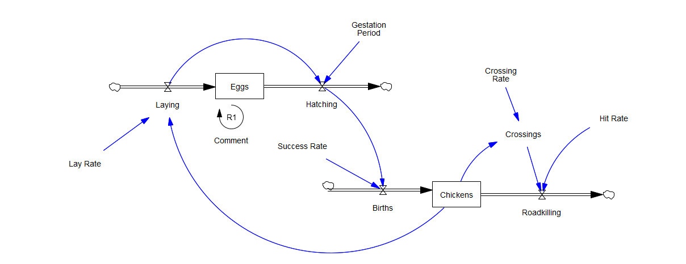

The average laying rate was approximated at 1 egg for every 5 chicken\*days, Assume for now that the gestation period is 2 weeks (14 days), and that 90% (0.9) of eggs hatch successfully. The equations defining the behavior of the model are as follows:

Births = Hatching \* Success Rate

Chickens = INTEG( Births , 100)

Eggs = INTEG( Laying - Hatching , 50)

Hatching = DELAY FIXED ( Laying ,Gestation Period , 20)

Laying = Lay Rate \* Chickens

We set the initial conditions such that there are 100 chickens, 50 eggs, and 20 eggs hatch while we're waiting for the gestation delay to catch up. Running the loop, the behavior observed is - exponential growth:

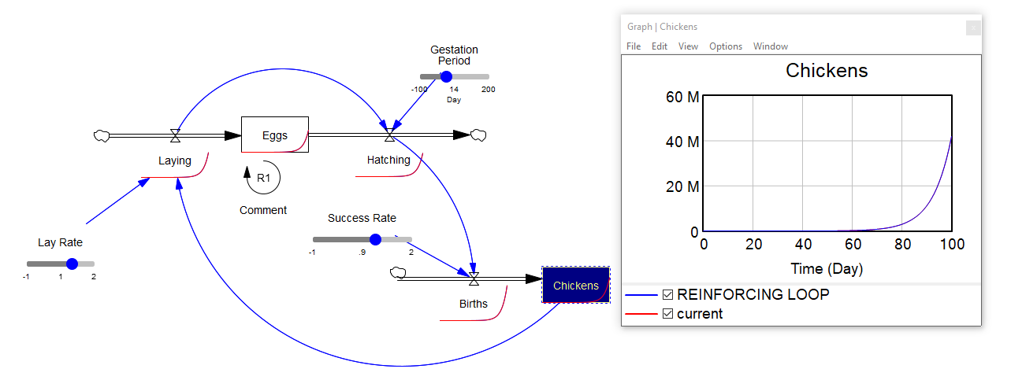

the balancing loop; the number of chickens which fall victim to cars and other automotive predators is dependent upon the chickens' propensity to cross roads, and the likelihood that any particular road crossing will prove fatal:

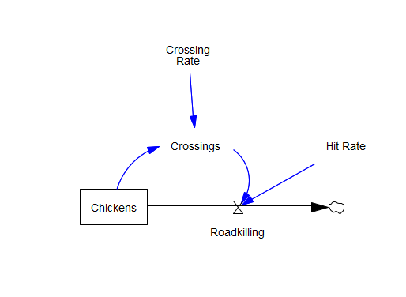

As before we'll take the initial stock of chickens to be 100, and assume (completely without justification) that chickens cross the road once every 5 days, and each crossing has a 20% (0.2) chance of being a chicken's last. The equations which define the behavior of this loop are:

Chickens = INTEG( - Roadkilling , 100)

Crossings = Chickens \* Crossing Rate

Roadkilling = Crossings \* Hit Rate

In this case we see that the stock of chickens declines exponentially:

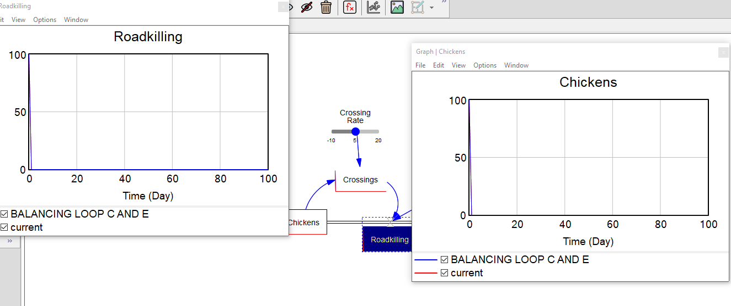

combine the two loops at Chickens;

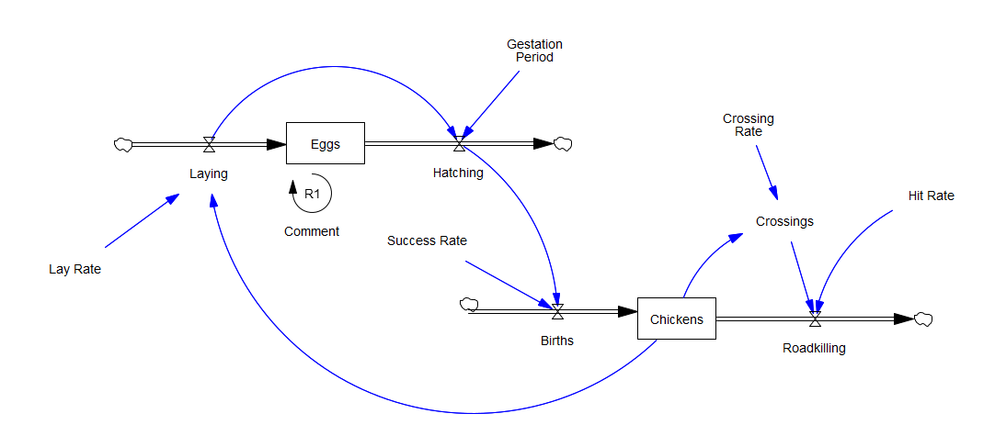

A hypothesis here is that the strength of the loops will be dependent on the 'Lay Rate' and the product of 'Crossing Rate' and 'Hit Rate'. The 'Gestation Period' may allow for some interesting periodic behavior. Using the initial conditions and parameter values that we defined for the individual loop cases, we get the following behavior:

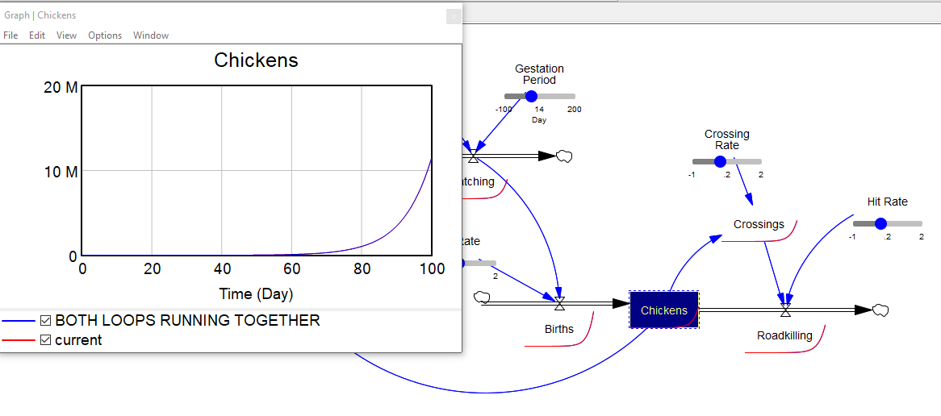

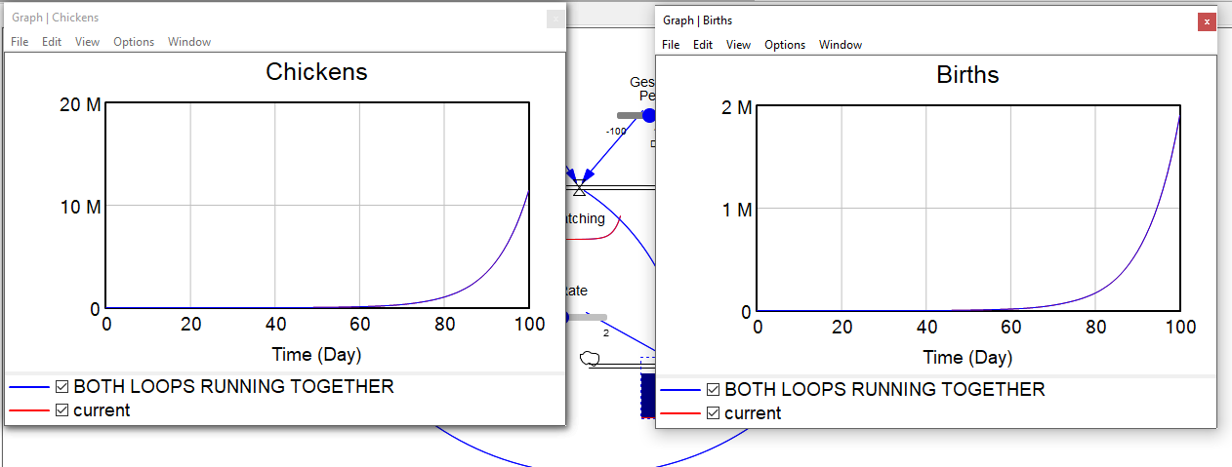

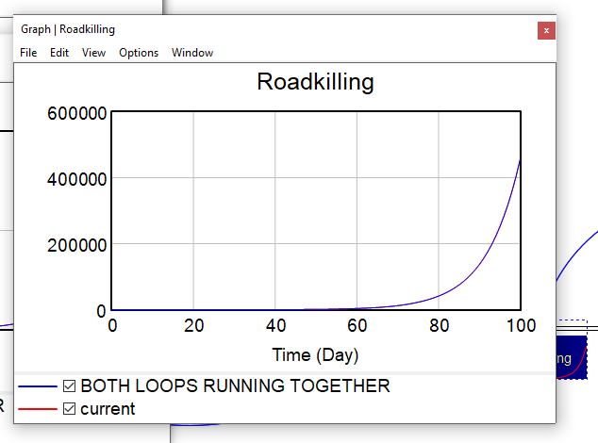

Both Births and Roadkillings grow exponentially, but the birth loop dominates, and so the overall chicken population also grows exponentially. This growth isn't as fast as that of the reinforcing loop alone, and after 100 days, the population reaches about appx 1.5M, much less than 10M+ of the reinforcing loop alone. The structural behavior of the overall system follows the dominant loop, but the subordinate loop has a large impact on the quantitative behavior.

2.

A.

US Real GDP: Over the long run, GDP is determined by the main factors of production, specifically, labor (including worker skills and knowledge, i.e., human capital), capital (plant and equipment), and technology (knowhow).

R1 is the basic positive feedback driving population growth. Population growth leads to growth of the labor force and hence real GDP. R2 describes the process of capital accumulation: some fraction of total output is invested in plant and equipment; as the capital stock grows, output rises further.

R3 describes the analogous process of knowledge accumulation: as output rises, some fraction is invested in R&D and other know-how generating activities; these add to the stock of productive knowledge, augmenting productive capacity. R4 shows human capital - worker knowledge and skills - an analogous process resulting from the investment of some fraction of output in education and training. As worker skill and productivity grow, so does output, increasing the resources available for still more education and training.

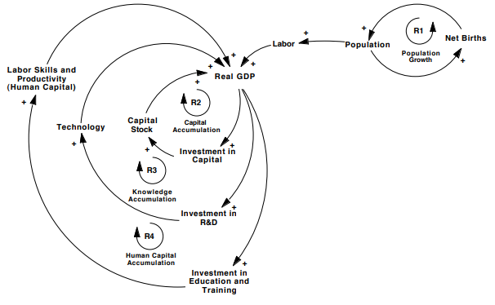

a richer society (with high consumption per capita) will tend to invest a larger fraction of total output in capital, research, and education than a poor one (one operating near the subsistence level). That is, as the harvest rises above the subsistence level, people can set aside a larger fraction of the harvest as seed corn to increase production next year even more. These loops control the strength of the main capital, technology, and human capital accumulation loops. As the fraction invested rather than consumed rises, capital and knowledge accumulate at a faster rate (relative to population), boosting output per capita even more. Takeoff into the robust economic growth of the industrial and post-industrial era occurs when loops R2-4 become stronger than the population growth loop R1, thus triggering a rise in living standards that then causes even faster capital and knowledge accumulation.

Negative/balancing loop: If population growth outstrips economic growth, the standard of living falls, reducing net births (primarily through increased mortality) until the population falls to be consistent with GDP.

B.

World Population Growth: The most basic feedback driving population growth is the positive Population-Births loop shown as R1. However, succinctly observing the world population growth data show that the fractional growth rate has not been constant. Before the industrial revolution, growth was generally slow and variable. As industrialization and development got underway, improvements in living standards, nutrition, sanitation, and public health caused a dramatic decline in mortality. Family size and birth rates remained high for several generations, so fractional population growth rates rose and population growth accelerated. In early industrializing nations, family size norms and birth rates gradually declined, slowing the population growth rate. In this diagram, average life expectancy rises with improvements in health care, sanitation, and so on that come with rising incomes. Lower mortality boosts population and, without sufficient economic growth, lowers income per capita until mortality rises enough to stabilize population (loop B2). Similarly, hard poverty lowers fertility until births decline to balance deaths (loop B3). Loop R2 shows a demographic transition. As income per capita rises through the development of an industrial economy, the cost of having children rises, and the age at which children can contribute to family welfare rises. Further, reduced mortality means women do not need to bear as many children to ensure that a few will survive long enough to take care of their parents in their old age. These economic pressures gradually cause a reduction in desired family size and hence births. Because family size and fertility patterns are strongly influenced by cultural and religious norms there is a long delay in the adjustment of desired family size and births. Loops R3-4 summarize the drivers of economic growth. As an economy begins to industrialize, income per capita rises. The immediate effect is a drop in mortality and rise in fertility, and population growth soars. Gradually, as cultural norms change, desired family size falls, and births decline until the population comes roughly into balance.

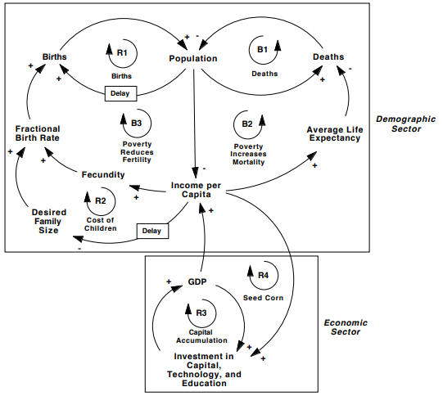

C.

US Prison Population:

Some fraction of the (adult) population are likely to commit crime; likelihood of arrest, prosecution, conviction and prison time determine the incarceration rate. Prisoners are released after some average sentence duration. If these parameters are constant the prison population will grow in steady state at the same rate as the population.

Some however believe prison does not rehabilitate convicts or provide them with training and skills that would enable them to make it on the outside, thus increasing the risk that they will commit new crimes upon release for economic reasons. Others argue that prison erodes self-reliance and coping skills, leading to a culture of dependency that leads some ex-convicts to commit violations so as to return to the relative safety of prison. Growth in prison population will also require growth in the number and capacity of prisons., the gain i.e benefits from the crime compared to the loss (prison time), likelihood of arrest among many others.

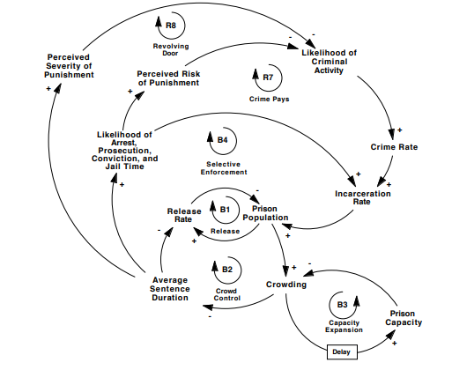

D. Semiconductor Performance:

2ND PART.

A.

Semiconductor Fabrication Defect Rate: Goal-seeking processes consist of negative feedback loops. Negative loops are self-correcting. Corrective actions respond to the sign and magnitude of the gap, bringing the state of the system in line with the goal. Defects (Defect Rate) are generated by a stock of underlying process problems. The stock of process problems is reduced through defect elimination. The rate of defect elimination depends on the potential for process improvement, which is proportional to the difference between the current defect rate and the theoretical minimum defect rate.

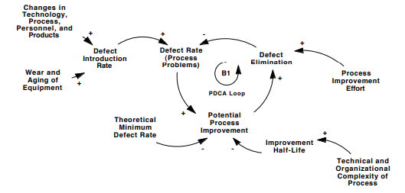

The theoretical minimum rate of defect generation is the goal of the negative loop; the current defect rate is the state of the system. Even under the best imaginable circumstances, the time required to build a house or the cycle time for semiconductor fabrication will be greater than zero. The improvement half-life is the time required to reduce the gap between the current and desired defect rate by half. The shorter the half-life, the faster defects can fall for any given level of improvement effort.

Defect elimination does not occur simply because there is potential for improvement, but requires a meaningful process improvement effort. Such effort requires resources: employees must devote part of their time to improvement effort, and must receive appropriate training, tools, and support. There are many forces and feedbacks that might prevent the defect rate from reaching zero. First, the theoretical minimum may exceed zero, also are cases in which new process problems arise even as improvement effort eliminates existing ones. The diagram shows the defect introduction rate rising through wear and aging of equipment and through changes in the firm’s technology, production process, personnel, and product mix. Even if the minimum potential defect rate is zero, the equilibrium defect rate will be greater than zero if these changes generate a flow of new process problems.

3RD PART

Identify the negative loops and time delays that might be responsible for the oscillations in economic affairs illustrated by Figure 4-7. Identify the state of the system, the goal, the corrective action, and delays. Estimate the length of the time delays you identify

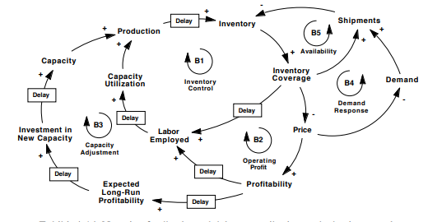

Inventories of finished goods accumulated production less shipments. As inventory coverage (inventories relative to shipments) fall, firms find themselves without enough goods to meet demand, and seek to boost production. While overtime provides some scope for rapid adjustments of capacity utilization, a large enough surge in demand requires firms to increase their labor force. It takes time for firms to recruit, hire, and train new workers. As they do, unemployment falls and utilization rises, boosting production (the Inventory Control loop B1). At the same time, low inventory coverage (or increased delivery times) will tend to push prices up. Higher prices and profitability eventually lead firms to boost their employment and production (the Operating Profit loop B2). If profitability remains high enough, long enough, firms will eventually raise their expectations about long-run profitability and boost investment. After a long construction delay, capacity and production rise, and inventory levels recover (the Capacity Adjustment loop B3). High prices also tend to suppress demand, boosting inventory coverage (the Demand Response loop B4); the Availability loop B5 shows that shipments must fall, and customers must wait longer for delivery, when the products they desire are out of stock. Thus profits, prices, unemployment, capacity utilization, capacity, and other key economic variables are all regulated by a network of negative feedback loops, many of which contain significant delays. These delays cause production, inventories, profits, employment, and utilization to chronically over- and undershoot their equilibrium values.

3.

What are the limits to growth for the population of a city and the rise in production of commodities such as aluminum? Identify the negative feedback loops which halt the growth in each case. Identify the time delays in these loops which cause the overshoot and fluctuation.